Lab Exercise 17 - Routine Health Checks & Audits in MinIO

LAB OBJECTIVES
After completing this lab, you will be able to:
- Perform routine health checks using MinIO native tools
- Validate cluster readiness for upgrade
- Identify blocking issues before upgrade
- Generate an audit checklist for production

PART 1 — Basic Service Health Checks

STEP 1: Verify MinIO Is Running
ss -tulnp | grep 9000
Expected:
- MinIO process listening on port 9000

STEP 2: Check Liveness & Readiness Probes
Curl -I http://127.0.0.1:9000/minio/health/live

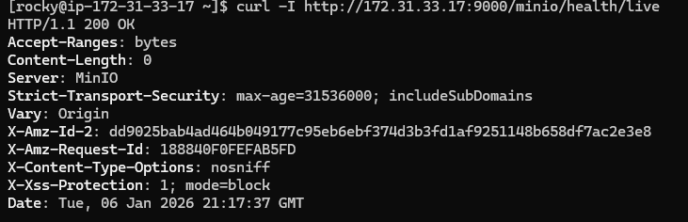
Curl -I http://127.0.0.1:9000/minio/health/ready
Expected:
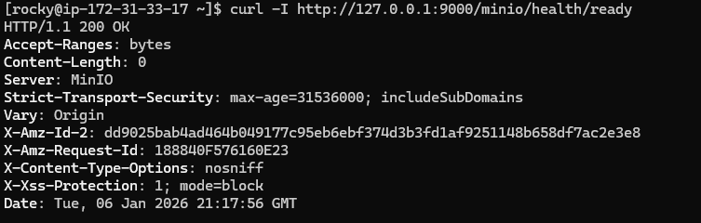Why this matters
- Upgrade should only proceed when both probes are healthy

STEP 3: Verify Server Status
mc admin info local
Check:
- Status: online
- No degraded nodes
- Correct MinIO version

PART 2 — Storage & Drive Health Audit

STEP 4: Verify Drive Availability
mc admin info local
Confirm:
- Drive state = ok
- No missing or offline disks

STEP 5: Check Disk Usage & Capacity
df -h /mnt/data
Upgrade prerequisite
- At least 20–30% free space recommended

STEP 6: Check Healing Status
mc admin heal local
Expected:
- No objects pending heal
Do not upgrade if healing is in progress

PART 3 — Data Protection & Integrity Checks

STEP 7: Versioning & Object Lock Audit
mc version info local/backup-lab

Check:
- Buckets with versioning enabled
- Buckets with object lock / WORM
Why:
- Upgrade must preserve immutability guarantees

PART 4 — IAM, Policy & Security Audit

STEP 8: Audit IAM Users
mc admin user list local

Confirm:
- No unknown users
- Disabled users are intentional

STEP 9: Audit Policies
mc admin policy list local
Verify:
- Custom policies documented
- No overly permissive policies

PART 5 — Replication & Lifecycle Audit

STEP 10: Replication Health (If Enabled)
mc replicate status local/source-bucket
Expected:
- No FAILED or PENDING replications

STEP 13: Lifecycle Rules Audit
mc ilm ls local/<bucket-name>

Confirm:
- Rules are intentional
- No accidental expirations during upgrade

